
Year 7 Integers and Data Mini Test
/47
Name: Date:
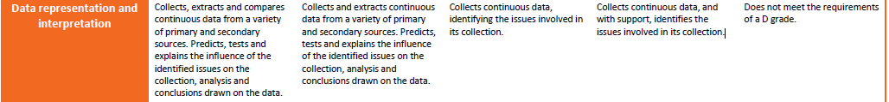
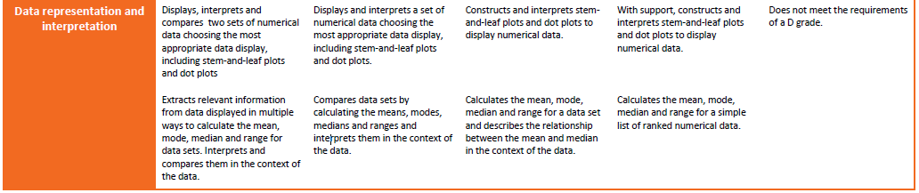
1 calculator and 1 A4 page of handwritten notes is allowed
Question 1 (5 marks)

Draw a line to connect the word to its correct meaning

Mean Most common number

Median The average

Range Data is much smaller or larger than most of the other data

Outlier Difference between largest and lowest

Mode Middle number of ordered data

Question 2 (3 marks)
Answer the following questions using the data below
58, 64, 53, 82, 77, 57, 64

Determine the range ___________________ Determine the mode _____________________
Determine the median __________________
A class of students have tested their best reaction times and the following results were obtained.
Question 3 (4 marks)
8, 10, 13, 14, 17, 19, 19, 23, 24, 28, 30, 35.
Put this data into an ordered stem and leaf below. (4 marks)

Key: 2|3 = 23
Question 4 (11 marks)
The below stem and leaf plots are the test results for 2 different classes.
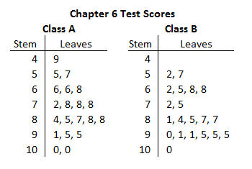
For Both classes find the following information.
Class A Class B
Median ____________

Mode ____________

Range ____________

Mean

Median ____________

Mode ____________

Range ____________

Mean

Comment on which class you believe scored the best? Explain your answer using the following terms at least once;
mean, mode, median, range, minimum, maximum (3 marks)

Question 5 (6 marks)
- A maths class recorded how many siblings they had. The results were; 3, 6, 1, 2, 0, 3, 5, 4, 2, 3, 4, 5, 2, 4, 0, 3, 2, 2, 1. Use the line below to create a Dot Plot of this data. (4 marks)

What is the least common number of siblings? (1 mark)?

What is the most common number of siblings? (1 mark)?

Question 6 2 marks

Order the following from lowest to highest:

-2, 6, -6, 3, 1, -1, 0 ____________________________________

Question 7 2 marks

Circle the highest number and underline the lowest number

- -6 -4 9 -12 2

- 0 15 -2 -21 19
Question 8 (2 marks)
Place either a < or > in between each set of numbers:

- -7 ___ -12 b) -5 ___ 4

Question 9 4 marks

- Complete the following:
- -5 + +2 = __________

- 8 - +3 = __________

  - 2 + -3 = __________

  - -12 - -11 = __________

Question 10 6 marks
Use the graph below to answer the following questions.

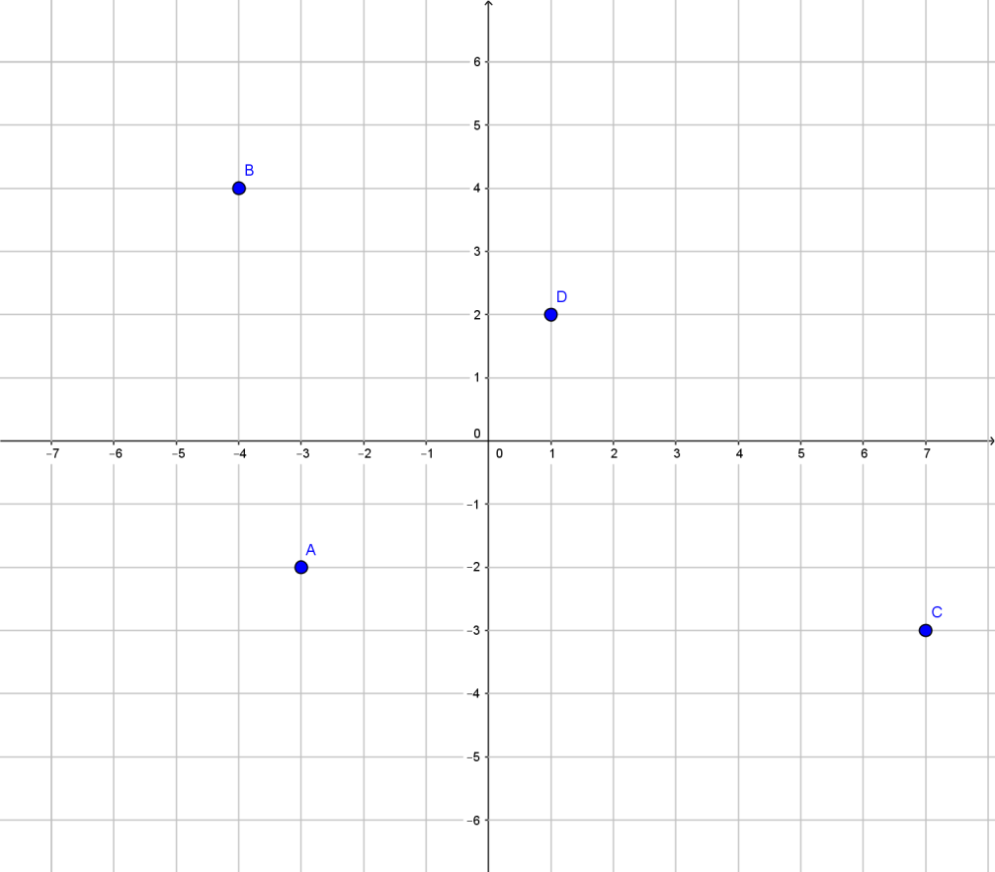

- Write the coordinates for A, B, C & D.

A ______ C ______

B ______ D ______

- Plot the following coordinates on the graph above.

E (6, 1) F (-1, -4)
Question 11 (2 marks)
Susan had $43 in the bank. She wants to buy a pair of shoes for $65. How much extra does she need?

End of test

